
Branding Audit Report
Current versus optimized LinkedIn profile and positioning
SAMPLE DATA. This report was generated from a fictional person and illustrative figures so you can see the finished format. It is not a real result.

Document control
Project | LinkedIn Influence Lab (Phase 1, 6 weeks)
Project code | LIL-2025-P1
Document | Branding Audit Report
Prepared for | Arjun Nair (Sample), Data Analyst
Learning path | Job Seeker
Version / date | 1.1 · 13 November 2026
Classification | Confidential: client use

1. Summary
19/100  Profile health score | Starting out  Assessment | 10  Checklist gaps | 4  Content pillars

The profile scores 19 out of 100 against a 12-point checklist drawn from the project brief. 10 items need attention; the five highest-value fixes are listed in section 3.

2. Profile checklist
Checklist item | Points | Score | Status | Recommended fix
Professional profile photo | 8 | 8 | OK
Banner that states your value | 6 | 0 | Gap | Replace the default banner with one line on who you help and how.
Keyword-rich headline (60-220 chars) | 14 | 4 | Gap | Use: role | who you help / what you do | 2-3 skills. Avoid a bare job title.
About section with proof and a call to action | 14 | 3 | Gap | Write 600-1,500 characters: hook, proof, what you post about, how to reach you.
Custom profile URL | 4 | 4 | OK
Featured section populated | 8 | 0 | Gap | Pin your best post, a project, and a link that proves your skills.
15+ skills, top 3 pinned | 6 | 0 | Gap | Add relevant skills and pin the three you want to be known for.
3+ recommendations | 8 | 0 | Gap | Ask three colleagues or managers for specific recommendations.
Experience bullets include numbers | 12 | 0 | Gap | Rewrite each role with one measurable result.
Open to Work set (recruiters only) | 6 | 0 | Gap | Turn on Open to Work for recruiters only.
Posting at least 8 times a month | 8 | 0 | Gap | Start with the 6-week calendar from this project.
500+ connections | 6 | 0 | Gap | Send 5 personalised connection requests a day to peers and recruiters.

3. Priority actions
- Experience bullets include numbers: Rewrite each role with one measurable result. (up to +12 points)
- About section with proof and a call to action: Write 600-1,500 characters: hook, proof, what you post about, how to reach you. (up to +11 points)
- Keyword-rich headline (60-220 chars): Use: role | who you help / what you do | 2-3 skills. Avoid a bare job title. (up to +10 points)
- Featured section populated: Pin your best post, a project, and a link that proves your skills. (up to +8 points)
- 3+ recommendations: Ask three colleagues or managers for specific recommendations. (up to +8 points)

4. Headline: current and optimized
 | Headline
Current | Data Analyst
Option 1 | Data Analyst | SQL · Excel · Power BI | Open to Business Intelligence Analyst
Option 2 | Aspiring Business Intelligence Analyst | Turning SQL into results for hiring managers and recruiters in analytics
Option 3 | Data Analyst who ships: SQL, Excel | Looking for Business Intelligence Analyst roles

5. About section: optimized draft
Before you use it Source: Template engine. Replace every [bracketed placeholder] with a real, verifiable example before publishing.

I help teams get dependable SQL work done, and I am looking for my next role as a Business Intelligence Analyst.
What I bring:
• Built a Power BI dashboard for a retail project that exposed three low-margin product categories, and the team changed pricing on two of them.
• I once sent the same resume to 20 roles and heard back from almost none; tailoring it to each role changed that.
• Showing one real project beats listing ten tools.
What I write about: career insights, personal journey, industry trends, actionable tips.
Skills I use most: SQL, Excel, Power BI, Python, A/B Testing.
If you are hiring for Business Intelligence Analyst, message me. I reply to every note.

6. Content pillars
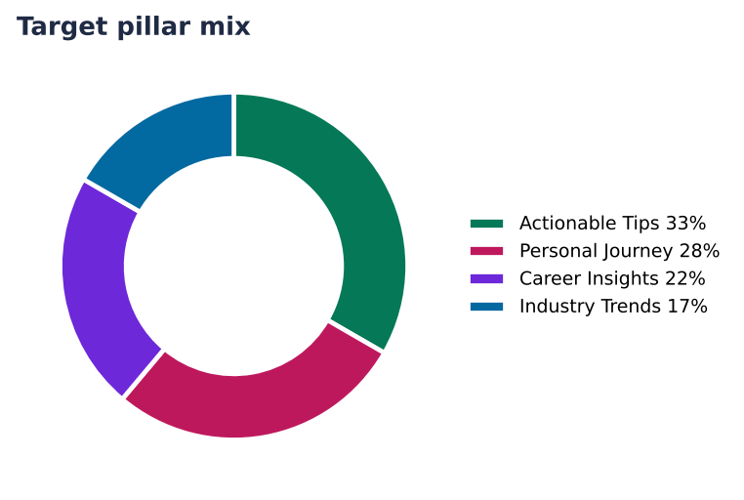
Figure 1. Target pillar mix for the six-week plan
Pillar | Share | Posts in 6 weeks | What it covers | Example topic
Actionable Tips | 33% | 6 | Checklists, templates and habits people can use today. | 5 minutes a day on SQL: the routine that actually stuck
Personal Journey | 28% | 5 | Honest stories: wins, mistakes and what you are learning. | My biggest mistake as a Data Analyst (and the lesson I still use)
Career Insights | 22% | 4 | Hard-won lessons about growth, promotions and decisions. | The best career advice I ignored for years (and what finally changed my mind)
Industry Trends | 17% | 3 | What is changing in your field, explained in plain English. | 3 shifts in retail analytics that hiring managers and recruiters in analytics should watch this quarter

7. Role-model benchmark
Role model | Profile | What to learn
Sample Analyst A | https://www.linkedin.com/in/sample-analyst-a | Posts a project walkthrough every week
Sample Recruiter B | https://www.linkedin.com/in/sample-recruiter-b | Explains what recruiters look for in analytics profiles

8. The three user paths compared
Path | Goal | Rhythm | Pillar mix | KPIs
Working Professional | Visibility and credibility inside my niche. | Tue, Wed, Thu | Career Insights 29%, Thought Leadership 24%, Industry Trends 24%, Actionable Tips 24% | Impressions, Comments, Profile visits
Job Seeker | Recruiter attention, interviews and inbound opportunities. | Mon, Wed, Fri | Actionable Tips 33%, Personal Journey 28%, Career Insights 22%, Industry Trends 17% | Profile visits, Recruiter messages, Connection requests
Thought Leader / Entrepreneur | Authority, followers, shares and inbound leads. | Tue, Thu, Sat | Thought Leadership 33%, Industry Trends 28%, Actionable Tips 22%, Personal Journey 17% | Followers gained, Shares, Inbound leads

